**SOLAR MOBILE CHARGER**

**INTEGRATED PROJECT REPORT**

**SUBMITTED BY**

Name of Students University Roll No.

Sarthak Chawla 1611981336

Anmol Wadhawan 1611981462

**SUPERVISED BY**

MRS. POOJA DHIMAN

Assistant Professor

Applied Sciences

April 2017



**CHITKARA UNIVERSITY, HIMACHAL PRADESH**

**CERTIFICATE**

I hereby certify that the work which is being presented here in the project entitled **“Solar Mobile Charger”,** is an authentic record of my own work carried out during a period from **January 2017 to April 2017 (2ndsemester)** under the supervision of (**Mrs Pooja Dhiman, Assistant Professor, Applied Sciences).**

**Signature of students**

Sarthak Chawla(1611981336) Anmol Wadhawan(1611981462)

Date: 28 April 2017 Place: Chitkara University, Himachal Pradesh

This is to certify that the above statement made by the students is correct to the best of my knowledge.

**ACKNOWLEDGEMENT**

Before we get into thick of things, We would like to add a few words of appreciation for the people who have been a part of the project right from its inception. The writing of this project has been one of the significant academic challenges. We have faced and without the support, patience and guidance of the people involved, this task would not have been completed. It is to them we owe our deepest gratitude.

It gives us immense pleasure in presenting this project report on **“Solar Mobile Charger”**. Its has been our privilege to have a team of project guide **Ms Jasmine Kaur**, who have assisted us from the commencement of this project. The success of this project is a result of sheer hardwork, and determination put in by us with the help of our project guide. We hereby take this opportunity to add a special note of Thanks! for **Mrs Pooja Dhiman**, who undertook to act as our mentor despite their many other academic and professional commitments. Their wisdom, knowledge, and commitment to the highest standards inspired and motivated us. Without their insight, support, and energy, this project wouldn’t have kick-started and neither would have reached fruitfulness.

We also feel heartiest sense of obligation to our team members and colleagues, who helped us in collection of data and resource material and also in its processing as well as in drafting manuscript. The project is dedicated to all those people, who helped us while doing this project.

**TABLE OF CONTENTS**

**INTRODUCTION**

Gone are the days when you would look up at the Sun and curse yourself for being out on a hot sunny day. Take pride very soon you will be a walking energy station with people asking you to help them charge their batteries with your clothes.

This isn’t a scene out of a Sci-Fi movie. It is the simple application of solar cells. They are the only way we can convert sunlight into electricity directly and day by day they are getting better, smaller and cheaper.

Nothing can dare challenge the sun when it comes to radiating energy. Every hour the energy available from the sun is more than what human’s require for an entire year. Petrol, diesel and all these fossil fuels are nothing but sun’s energy concentrated over years and years. This makes them very efficient in terms of energy per unit of the fuel. So why not tap it directly?

Solar energy isn’t something new. People have used sun to dry and preserve things. Vedic literatures in India even state the use of flying machines which were powered using the sun. Come 21st century, we have come a long way in developing solar cells which are the devices powering our future, converting sun’s energy into electricity.

Solar panels are simply solar cells lined up together in series and parallel so as get sufficient voltage and are p-n junction semiconductor devices with pure silicon wafer doped with ‘n’ type phosphorous on the top and ‘p’ type boron on the base. If the PV cell is placed in the sun, photons of light strike the electrons in the p-n junction and energize them, knocking them free of their atoms. These electrons are attracted to the positive charge in the n-type silicon and repelled by the negative charge in the p-type silicon. Connecting wires across the junction will have a current in them.



*Fig. 1 Light incidenting on solar panel*

Solar cells have come a long way from bulky 6% efficient chunks to thin films with as much as 30% efficiency. They are selling like hot cakes today given their necessity and utility. And the reason being they are faithful good chaps unlike oil which will soon be more precious to us than diamonds and the black monster: coal which has polluted the air, hand in cuff with the other fossil fuels. We need to understand solar panels so as to understand their applications. Today, we have mono-crystalline, polycrystalline and amorphous thin film panels. Mono-crystalline are so far the most efficient, given that they have the maximum silicon in a unit area so more current for the same number of photons. They are made out of a single silicon crystal as a continuous lattice. While for the polycrystalline panels, molten silicon is poured into moulds and separate boundaries can be seen due to this. Lesser quantity of silicon in a unit area means lesser efficiency of production of electricity. Amorphous thin film panels are layers of silicon on a glass surface and are the least expensive. Hence, they are used in applications where you can do away with efficiency for lowering the costs.

Even 15% efficient solar panels installed across the world’s wastelands can produce enough clean energy to sustain mankind for a year.



*Fig.2*

Yet new technology is continuously being developed though solar energy generation is still in its infancy. The concept of SOLAR FARMING is new and catching up fast in investors. India is a tropical country and can soon become the Saudi Arabia of solar energy. With Concentrated Photo Voltaic (CPV : which increase efficiency by concentrating large amount of sunlight on the solar cells using mirrors) coming up in India, we are definitely headed towards a cleaner future.

Reducing dependence on fossil fuels and cutting down on our carbon emissions is one of the most important aspects of solar energy. Another crucial point is it can make any country, especially tropical ones like India, self-sufficient in energy. With ambitious project like the National Solar missions aiming at producing 20GW (India’s energy consumption 2012: 100GW out of which 1GW was Solar energy) by 2020 is a big step toward progress. Rural areas are now lit up with solar lamps. Solar parks are also an emerging trend with Charanka Solar Park, Gujarat producing 20MW of energy. Government is also taking initiatives to encourage people to make use of the sun by subsidizing electricity bills for consumers using the solar panels. So if you make more energy than you use, you will end up in a profit without even burning a calorie!

Going Solar is exciting but some challenges also need to be addressed. Space constraints, weather constraints and expensive technology involved do hinder the process. But with increase in production and development of technology, prices will fall, demands increase and we will be living in a cleaner, safer environment, making the energy we need. Renewable sources of energy alone can ensure sustainable development. Economic growth can also be ensured by energy reaching to each and every household in turn increasing the productivity of industries and standard of living of people. It is a bright future we have ahead of us; the only thing is we need to focus the glare rather than evading it.

**COMPONENTS USED**

**1.Solar panel:**

Solar panels absorb the sunlight as a source of energy to generate electricity or heat. A photovoltaic (PV) module is a packaged; connect assembly of typically 6x10 photovoltaic solar cells. Photovoltaic modules constitute the photovoltaic array of a photovoltaic system that generates and supplies solar electricity in commercial and residential applications. Each module is rated by its DC output power under standard test conditions (STC), and typically ranges from 100 to 365 Watts (W). The efficiency of a module determines the area of a module given the same rated output – an 8% efficient 230 W module will have twice the area of a 16% efficient 230 W module. There are a few commercially available solar modules that exceed efficiency of 22% and reportedly also exceeding 24%. A single solar module can produce only a limited amount of power; most installations contain multiple modules. A photovoltaic system typically includes an array of photovoltaic modules, an inverter, and a battery pack for storage, interconnection wiring, and optionally a solar tracking mechanism.

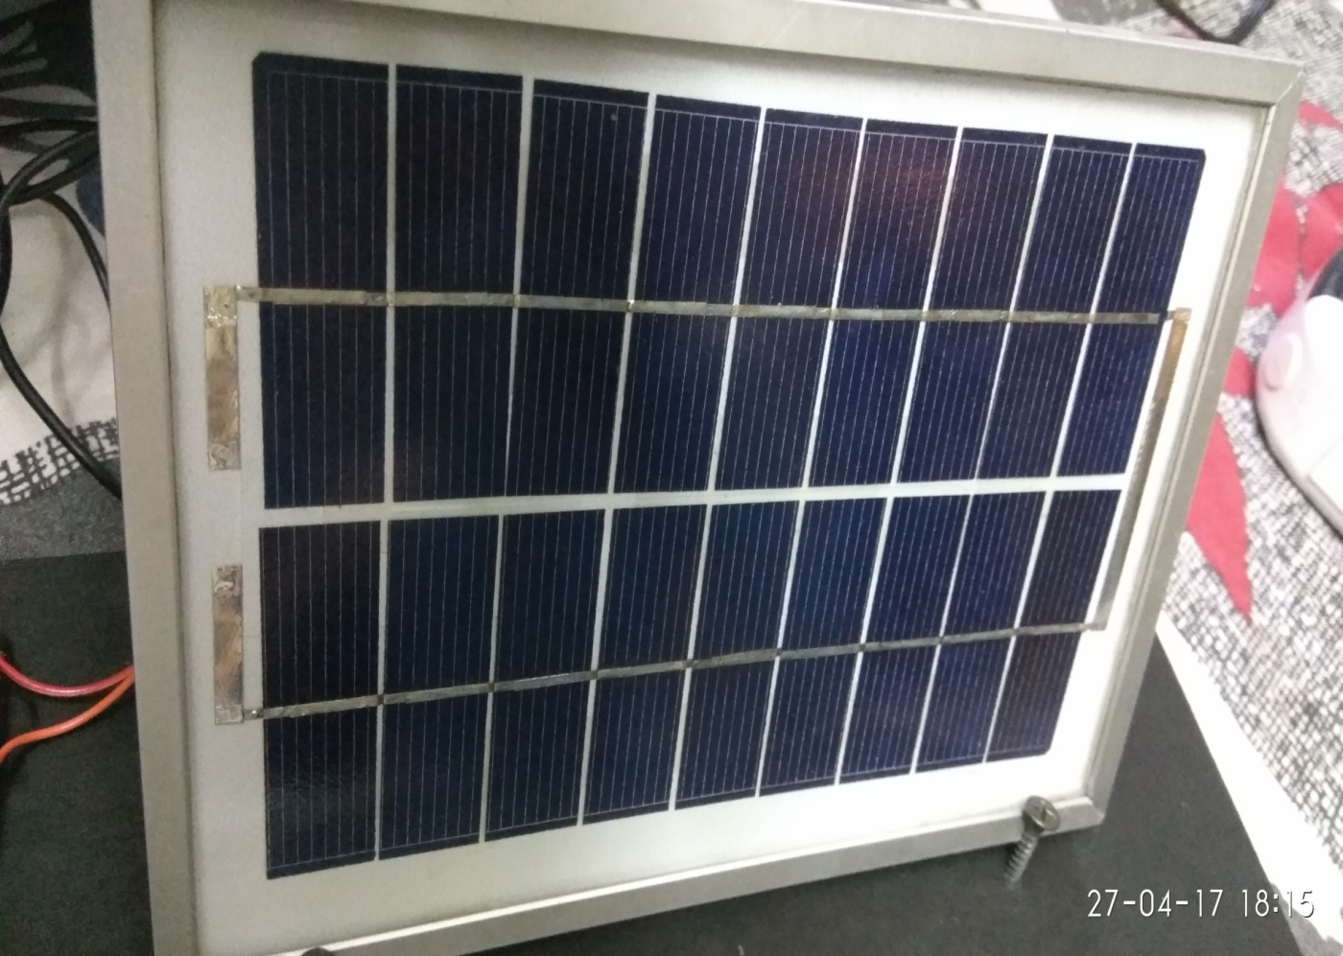

*Fig. 3 Solar Panel*

**Specification of solar panel we used:**

Maximum power Pmax 3Watt

Voltage at max power Vmp 10.5Volt

Current Imp 0.24Ampere

Open circuit current Voc 10.5Volt

Tolerance Isc 0.22Ampere

Maximum system voltage +-5%

6Ampere

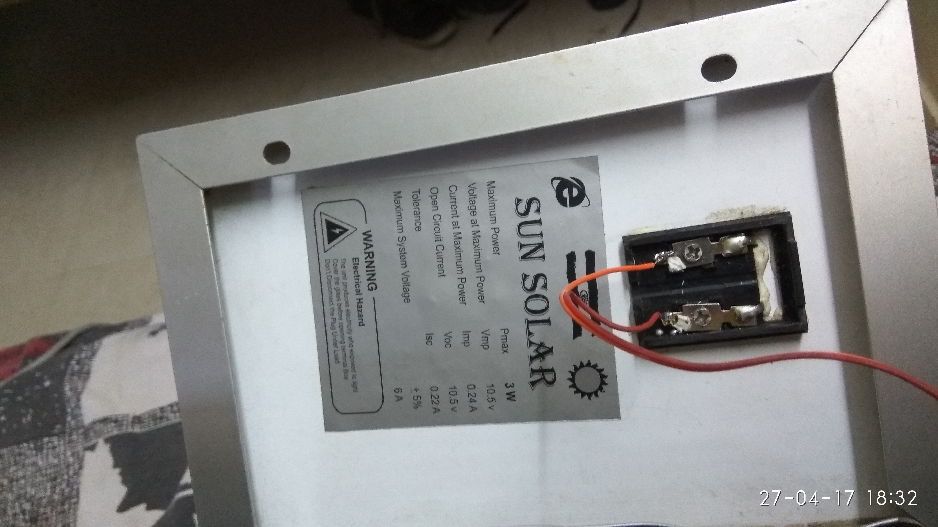

*Fig. 4 Back side of solar panel*

**2.IC7805:**

Voltage sources in a circuit may have fluctuations resulting in not giving fixed voltage outputs. Voltage regulator IC maintains the output voltage at a constant value. 7805 IC, a voltage regulator integrated circuit (IC) is a member of 78xx series of fixed linear voltage regulator ICs used to maintain such fluctuations. The xx in 78xx indicates the fixed output voltage it provides. 7805 IC provides +5 volts regulated power supply with provisions to add heat sink as well. Let’s look into some of the basic ratings to get an overview.

**7805 IC Rating**

* Input voltage range 7V- 35V
* Current rating Ic =1A
* Output voltage range

VMax=5.2V

,VMin=4.8V

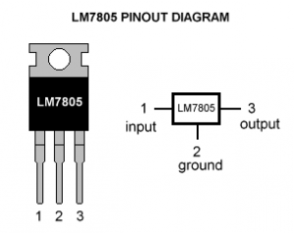

*Fig. 5 Pin out diagram*

# Pin Details of 7805 IC

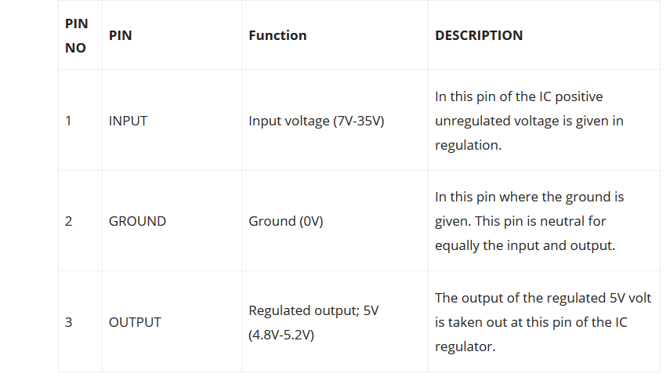

# *Fig. 6 Pin details*

# The difference between the input and output voltage appears as heat. The greater the difference between the input and output voltage, the more heat is generated. If too much heat is generated, through high input voltage, the regulator can overheat. If the regulator does not have a heat sink to dissipate this heat, it can be destroyed and malfunction. Hence, it is advisable to limit the voltage to a maximum of 2-3 volts higher than the output voltage. So the two options are, design your circuit so that the input voltage going into the regulator is limited to 2-3 volts above the output regulated voltage or place an appropriate heat sink that can efficiently dissipate heat.

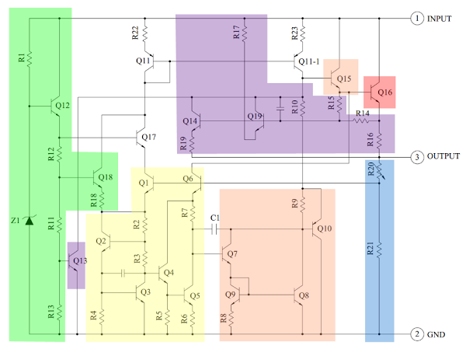

# *Fig.7 Schematic diagram*

# 3.Lithium ion battery:

A **lithium-ion battery** or **Li-ion battery** (abbreviated as **LIB**) is a type of rechargeable battery in which lithium ions move from the negative electrode to the positive electrode during discharge and back when charging. Li-ion batteries use an intercalated lithium compound as one electrode material, compared to the metallic lithium used in a [non-rechargeable](https://en.wikipedia.org/wiki/Primary_battery) lithium battery. The electrolyte, which allows for ionic movement, and the two electrodes are the constituent components of a lithium-ion battery cell.

Lithium-ion batteries are common in home electronics. They are one of the most popular types of rechargeable batteries for portable electronics, with a high energy density, tiny memory effect and low self-discharge. Beyond consumer electronics, LIBs are also growing in popularity for military, battery electric vehicle and aerospace applications.[[9]](https://en.wikipedia.org/wiki/Lithium-ion_battery#cite_note-9) For example, lithium-ion batteries are becoming a common replacement for the lead–acid batteries that have been used historically for golf carts and utility vehicles. Instead of heavy lead plates and acid electrolyte, the trend is to use lightweight lithium-ion battery packs that can provide the same voltage as lead-acid batteries, so no modification to the vehicle's drive system is required.

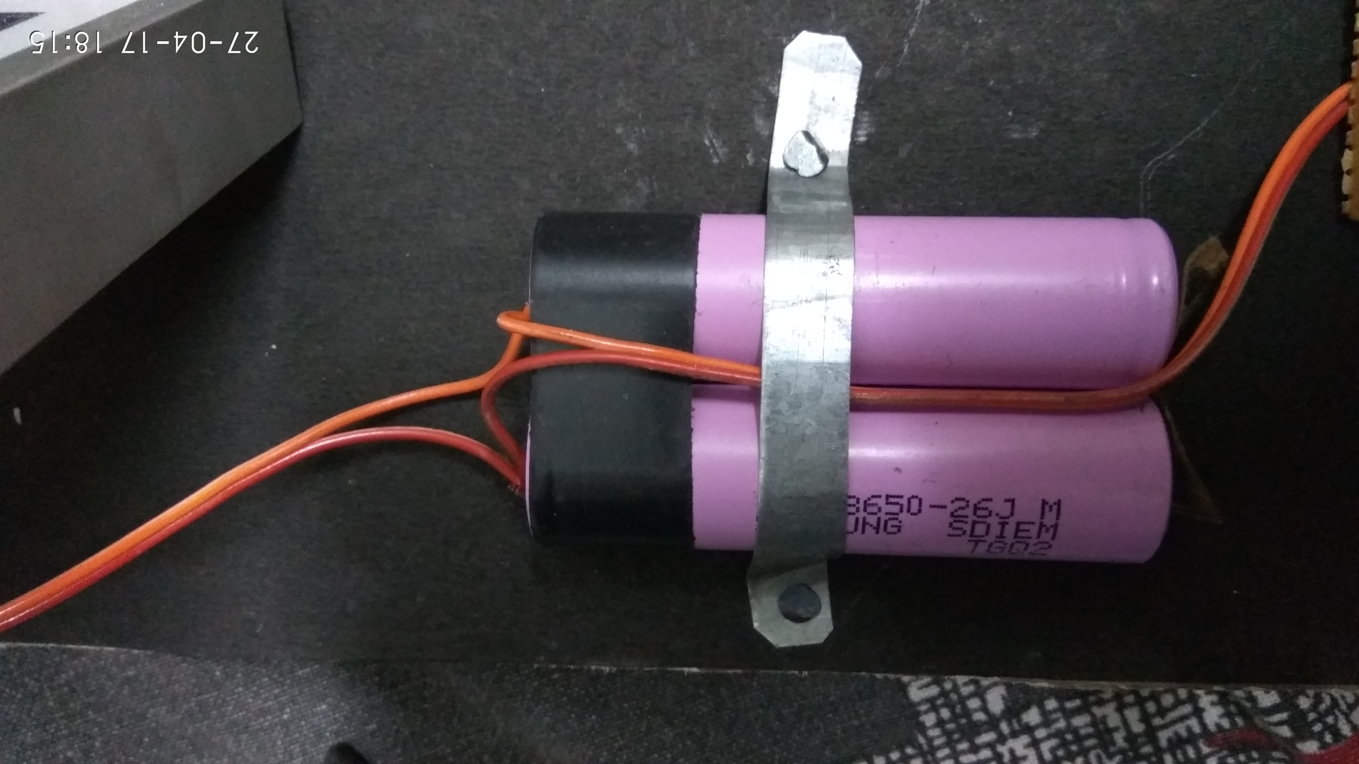

*Fig.8 Lithium ion battery*

**4.PCB(Printed Circuit Board):**

A printed circuit board (PCB) mechanically supports and electrically connects electronic components using conductive tracks, pads and other features etched from copper sheets laminated onto a non-conductive substrate. Components (e.g. capacitors, resistors or active devices) are generally soldered on the PCB. Advanced PCBs may contain components embedded in the substrate.PCBs can be *single sided* (one copper layer), *double sided* (two copper layers) or *multi-layer* (outer and inner layers). Conductors on different layers are connected with vias. Multi-layer PCBs allow for much higher component density.FR-4 glass epoxy is the primary insulating substrate. A basic building block of the PCB is an FR-4 panel with a thin layer of copper foil laminated to one or both sides. In multi-layer boards multiple layers of material are laminated together. Printed circuit boards are used in all but the simplest electronic products. Alternatives to PCBs include wire wrap and point-to-point construction. PCBs require the additional design effort to lay out the circuit, but manufacturing and assembly can be automated. Manufacturing circuits with PCBs is cheaper and faster than with other wiring methods as components are mounted and wired with one single part. A minimal PCB with a single component used for easier prototyping is called a breakout board. When the board has no embedded components it is more correctly called a *printed wiring board* (*PWB*) or *etched wiring board*. However, the term printed wiring board has fallen into disuse. A PCB populated with electronic components is called a *printed circuit assembly* (*PCA*), *printed circuit board assembly* or *PCB assembly* (*PCBA*). The IPC preferred term for assembled boards is *circuit card assembly* (*CCA*), and for assembled backplanes it is *backplane assemblies*. The term PCB is used informally both for bare and assembled boards. The world market for bare PCBs exceeded $60.2 billion in 2014.

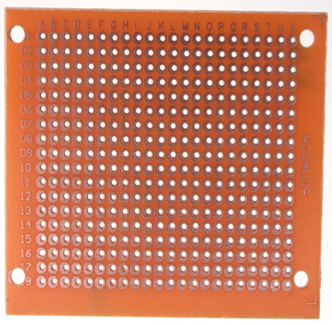

*Fig.9 PCB*

**5. Micro USB Cable:**

Micro-USB connectors, which were announced by the USB-IF on 4 January 2007, have a similar width to Mini-USB, but approximately half the thickness, enabling their integration into thinner portable devices. The Micro-A connector is 6.85 by 1.8 mm with a maximum overmold boot size of 11.7 by 8.5 mm, while the Micro-B connector is 6.85 by 1.8 mm with a maximum overmold size of 10.6 by 8.5 mm. The thinner Micro-USB connectors were introduced to replace the Mini connectors in devices manufactured since May 2007, including smart phones, personal digital assistants, and cameras. While some of the devices and cables still use the older Mini variant, the newer Micro connectors are widely adopted, and as of December 2010 they are the most widely used. The Micro plug design is rated for at least 10,000 connect-disconnect cycles, which is more than the Mini plug design.The Micro connector is also designed to reduce the mechanical wear on the device; instead the easier-to-replace cable is designed to bear the mechanical wear of connection and disconnection. The *Universal Serial Bus Micro-USB Cables and Connectors Specification* details the mechanical characteristics of Micro-A plugs, Micro-AB receptacles (which accept both Micro-A and Micro-B plugs), and Micro-B plugs and receptacles, along with a standard-A receptacle to Micro-A plug adapter.

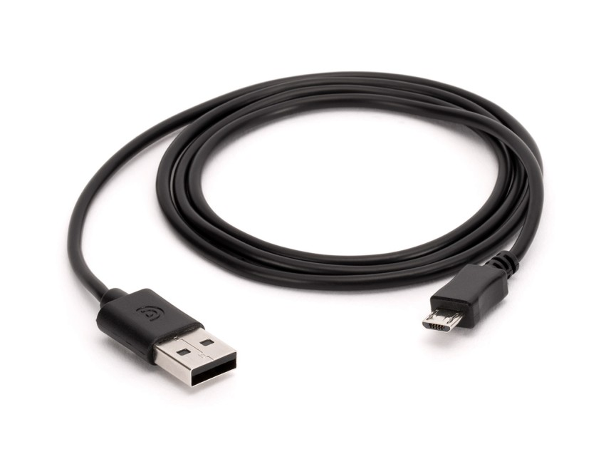

*Fig.10 Micro USB cable*

**6. Connecting Wires:**

A **wire** is a single, usually cylindrical, flexible strand or rod of metal. Wires are used to bear mechanical loads or electricity and telecommunications signals. Wire is commonly formed by drawing the metal through a hole in a die or draw plate. Wire gauges come in various standard sizes, as expressed in terms of a gauge number. The term *wire* is also used more loosely to refer to a bundle of such strands, as in "multistranded wire", which is more correctly termed a wire rope in mechanics, or a cable in electricity. Wire comes in solid core, stranded, or braided forms. Although usually circular in cross-section, wire can be made in square, hexagonal, flattened rectangular, or other cross-sections, either for decorative purposes, or for technical purposes such as high-efficiency voice coil in loudspeakers. Edge-wound coil springs, such as the Slinky toy, are made of special flattened wire.

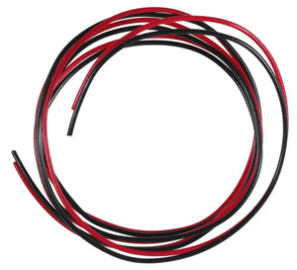

*Fig.11 Wires*

**PROCEDURE**

1. Connect the circuit as shown in the figure below and then solder the components with the wires accordingly.

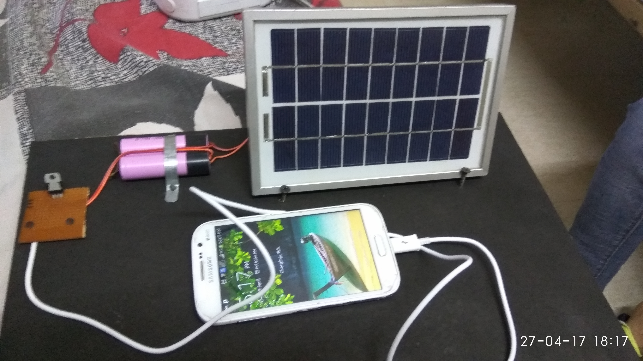

*Fig.12 Solar Mobile Charger*

2. Place the whole project in direct sunlight so as the solar panel can get maximum sunlight.

3. Connect the mobile to the mini USB outlet.

4. The mobile starts charging.

5. We can make our battery in project get charged first then can use the project as a power bank and can charge the mobile later whenever required .

WORKING PRINCIPLE

The solar mobile charger is just device working on the conversion principle of voltage using ICs, diodes, capacitors, resistors and various other electrical equipments in simple words solar panel uses photovoltaic cell or solar cells to convert solar energy in electrical energy. Output of these panels may vary from panels to panels .We can use any of these according to our need. Further we use ICs and other equipments and create a circuit to convert the input power supply coming from the solar panel into the desired power supply i.e. 2 amperes 5 volts dc . Although the adapters we use today for charging our phones today via charging cords i.e. usb wires connected to them, use input ac supply of 100-240 volts ~50-60 hertz 0.35amperes as standard for charging the modern day Smartphone. Many other companies have their own standards for input and output supplies the above one was of well known upcoming brand “MI”. At last we can say that we are basically just converting the supply we get from the solar panels into the ones we require in this case the one for the mobile charger.

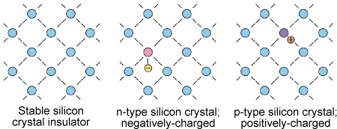

*Fig.13 Inside of a solar panel*

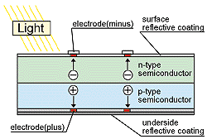

*Fig.14 Solar panel placed under sunlight*

**APPLICATIONS:**

* For low-power portable electronics, like calculators or small fans, a photovoltaic array may be a reasonable energy source rather than a battery.
* In other situations, such as solar battery chargers, watches, and flashlights the photovoltaic array is used to generate electricity that is stored in batteries for later use.
* By using over voltage protection circuit we can protect our battery from over charging Charge discharge control circuit contain two-way Switch. It gets active when voltage exceeds above threshold voltage level.

**ADVANTAGES:**

* Cost Effective: Compared to the other mobile chargers, the solar chargers are cost effective as it absorbs power from the sun. It does not require electric power
* Versatile: It is also known to be versatile as it can be used for all types of mobile phones
* Uninterrupted Power Supply: One of the greatest advantages of solar mobile phone charger is that it can be used to charge mobiles even during power outages.
* Emergency Purposes: Another benefit is that it hardly requires any electrical outlet. It can therefore be used during emergencies and outdoor purposes.
* Compact Design: Solar mobile phone chargers are compact in size and easy to carry around.

**LIMITATIONS:**

* Quite expensive: One of the most important drawbacks isits price compared to the ordinary mobile phone chargers, it is quite expensive as it utilizes solar energy captivators.
* Charging time large: Another significant drawback is the time frame required by the chargers to charge mobile phones. It can take six to eight hours to charge mobile phones compared to the other.

**CONCLUSION:**

Renewable energy is not a new concept, nevertheless at an exponential growing population, the development and improvement of them are essential to sustain world power hunger. In 2050 the population expectation on earth is about 9 billion people, where approximately 5 billion will use mobile phones. The application of renewable energy at portable devices starts to plays a significant role at global energy saving. Solar chargers are simple, portable and ready to use devices which can be used by anyone especially in remote areas.

**FUTURE SCOPE:**

Basically the solar mobile charger is designed for charging mobile battery. But in future, by making some modifications we can use this charger to charge batteries used in different portable devices like laptop, walky-talky,i-POD, digital camera etc.

**ABSTRACT:**

* Solar energy is a clean energy source and it is high time we understand its importance and embrace it in our daily lives.
* Solar cells are the heart of any circuit. In the circuit for this project, Solar panels were used as a power supply and fed into a voltage regulator so as to have a constant voltage charging for the battery.
* Batteries are the easiest way to store energy. Hence solar charger circuits aim at charging batteries rather than driving components.
* Rechargeable batteries like Lead Acid, Li-ion and NiMH are used depending on the user’s requirements. Here we have used sealed Lead Acid ones.
* It is also very necessary to cut off charging once the battery is fully charged. This is managed using a zener diode which switches on at the cut-off voltage and diverts the current through the transistor.
* The battery is thus charged at constant voltage and at desired rate depending on the amount of current supplied.
* Solar energy is the most abundant but least used source of energy. But it’s the solution to most of our problems
* The major challenges we face in going solar is expensive technology, limited space and energy. We need to address them by having more efficient materials and most importantly awareness among people so that they use it to their benefits.

**REFERENCES:**

* Park “Overview of Energy Harvesting Systems (for Low-Power Electronics).” Presentation at the First Los Alamos National Laboratory Engineering Institute Workshop: Energy Harvesting, 2005 .
* Ferro Solutions. “VEH-360: Evaluation Power System Specifications.”
* J .A. Paradiso and T. Starner. 2005. “Energy scavenging for mobile and wireless electronics.” Pervasive Computing 4(1):18–27.
* EnOcean. Perpetuum International Edition4http://tinyurl.com/2lxbo5 (orwww.enocean.com/fileadmin/redaktion/pdf/perpetuum/perpetuum_ 06_en.pdf), 2007.
* C. Park and P. Chou , “Power utility maximization for multiple-supply systems by a load-matching switch”, Proc. ACM/IEEE International Symposium on Loss Power Electronics and Design, pp. 168–173, 2004.
* T. Voigt, H. Ritter, and J. Schiller, “Utilizing solar power in wireless sensor networks”, Proc. IEEE Conference on Local Computer Networks, 2003.
* Kansal, D. Potter, and M. Srivastava “Performance aware tasking for environmentally powered sensor networks”, Proc. ACM International Conference on Measurement and Modelling of Computer Systems, pp.223– 234, 2004.